IMPORTANT MOUNTING INFORMATION
ENSURE THE END USER IS AWARE OF THESE REQUIREMENTS
Towball requirements for Thule VeloCompact 927, VeloSpace 918, Velospace XT 938 & 939, EasyFold XT 933 & 934
Thule towball mount carriers 927, 918, 933, 934, 938 & 939 feature a precision towball coupling mechanism (the Hercules coupler) which is designed for use only with 50mm towballs meeting the ISO1103 standard (the so called ISO 50mm standard)
Illustrations of towballs meeting the ISO1103 standard are as illustrated below:
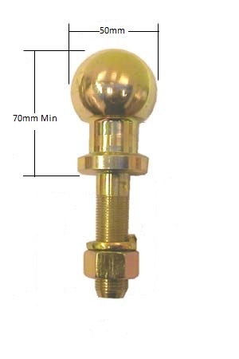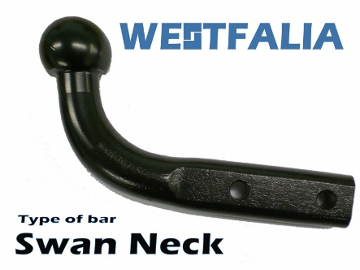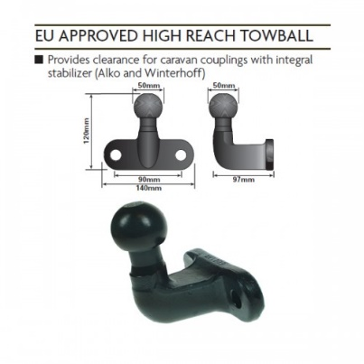
Thule carriers fitted with the Hercules coupler are not compatible with 1 7/8” (47mm) towballs commonly fitted to vehicles in New Zealand nor is the coupler compatible with “convert-a-ball” type towballs where the user can change between 1 7/8” and 50mm balls without demounting the towball shank
If the user has a conventional towbar with a flat tongue and wishes to install a 50mm towball to accommodate one of these Thule carriers, then the towball must be 70mm or greater in overall height and have the flat section on the underside of the ball like the gold coloured ball illustrated above
There are 50mm towballs in use and available for sale which are less than 70mm tall or feature a radius under the ball instead of a flat. These characteristics will result in the clamp mechanism not engaging correctly leading to either coupler damage, or an insecure carrier.
Please contact Roof Rack Systems NZ 03 3818141 or info@thule.co.nz to clarify any information contained in this instruction

European towball options:
- 3/4” (19mm) hole – no solution
- 7/8” (22mm) hole in towbar tongue (pretty rare as it’s an Australian size)? – Supercheap http://www.supercheapauto.co.nz/product/SCA-tow-ball-chrome-50mm/377729
- 25mm hole in the towbar tongue – Savebarn https://www.savebarn.co.nz/al-ko-hi-rise-50mm-aks-towball-3500kg-21214 or Supercheap http://www.supercheapauto.co.nz/Product/Trojan-Towball-High-Rise-Euro-Kit-50mm-1-Shank-T541031/SPO6456426
